BRITISH DRIVING SOCIETY, SHROPSHIRE AREA 27
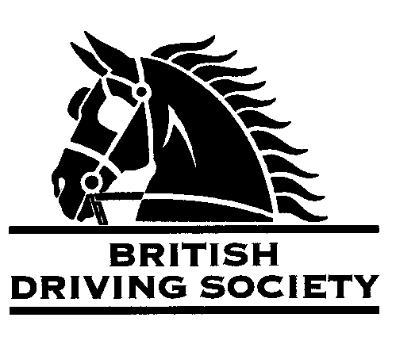
BDS MEMBERS, FAMILY & FRIENDS
ARE INVITED TO VIEW THE ANNUAL AREA MEETING, A WALK AROUND THE CARRIAGE COLLECTION FOLLOWED BY
THE ANNUAL AREA LUNCH

Mr & Mrs Russell Hand cordially invite you to view their stables,
Coach house and Carriage collection at
Jayroc Stables, Shawbury Heath, Shawbury, SY4 4EA
On Sunday 28th January 2024 between 12:00pm and 2:40pm.
Annual Area Meeting will commence at 1pm.
Tea & Coffee will be available
Strictly No Photography please
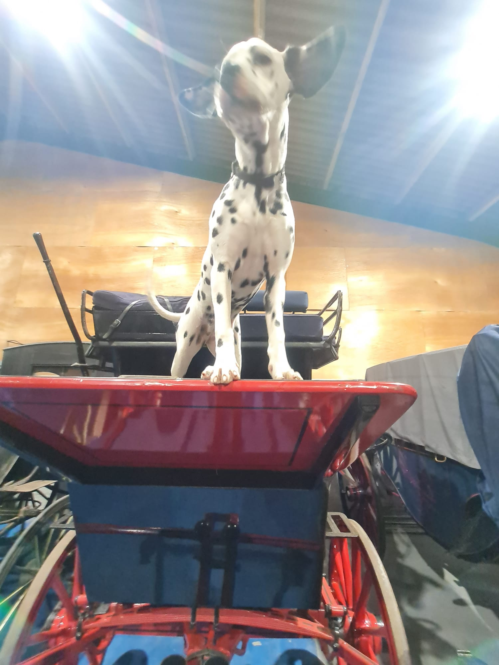
And afterwards, no earlier than 3pm,
to proceed to The Fox and Hounds, Wytheford Road, Shawbury, SY4 4JG
for luncheon. (Limited to 50)
Orders will be taken at the table – an extensive menu of starters, mains and desserts are available
Tariff:
1 course £18.95 2 courses £24.95 3 courses £29.95
Further details on: www.foxandhoundsshawbury.co.uk

Neither the Organizing committee, nor the British Driving Society, nor any Landowner, nor any agent, Employee or representative of these bodies accept any responsibility for any accident, loss, damage, injury or illness to any animal, person or property whatsoever, however caused. The Society takes reasonable precautions to ensure the Health and Safety of everyone present at each event. For these measures to be effective, everyone must take all reasonable precautions to avoid and prevent accidents occurring, and must obey instructions of the Organizer and all Official and Stewards.

Please compete this slip and return it to:
Jayroc Stables, Shawbury Heath, Shawbury, SY4 4EA or email to: dyno13@rhand.co.uk

NAME/S………………………………………………………………………………………………………………………………..............

NUMBER ATTENDING JAYROC & LUNCH…………NUMBER GOING STRAIGHT TO LUNCH ……………

MOBILE................................………………………………………………………………………………………………………………

Email…………………………………………………………………………………………………………………………………....................

I am a B.D.S. MEMBER, Membership No. …………………………..………..

