**BDS SHROPSHIRE AREA 27**

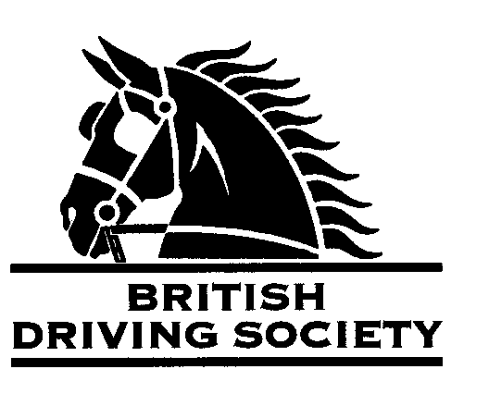

**EVENT** Midsummer drive by kind invitation of Mr and Mrs Beynon Brown. Approximately 12 miles on quiet roads.

**VENUE**  Bromley Hall, Bagley, Ellesmere, SY12 9BX.

**DATE** 22nd June 2024

**TIME** 10.30am for 11am departure

**ENTRY FEE** £5

Maps and full instructions will be given at the commencement of the drive.

Neither the Organising Committee nor the British Driving Society nor any Landowner nor any Agent, Employee or representative of these bodies accept any responsibility for any accident, loss, damage, injury or illness to any animal, person or property whatsoever, however caused.

The Society takes reasonable precautions to ensure the Health and Safety of everyone present at each event. For these measures to be effective,everyone must take all reasonable precautions to avoid and prevent accidents occurring and must obey the instructions of the Organizer and all Officials and Stewards.

**All** drivers and participants must agree to abide by the Rules of the British Driving Society available at [*www.britishdrivingsociety.co.uk*](http://www.britishdrivingsociety.co.uk/).

Correctly fitted hard hats that meet the latest safety regulations are recommended and are mandatory for participants under the age of 14. All drivers must be aged 8 years or older and all participants under 18 must be accompanied by a responsible adult.

CLOSING DATE FOR ENTRIES 15th June 2024

---------------------------------------------------------------------------------------------------------------------------------------------

Entry form for Bromley Hall Midsummer Drive 22nd June 2024

NAME

ADDRESS

POST CODE

TELEPHONE No MOBILE

Email  **_**

I am a B.D.S. MEMBER, Membership no._____________________________________________________________

Payment enclosed (cheque payable to BDS Shropshire) or online payment to British Driving Society Area 27 Lloyds Bank 30-96-26 Acc 801186600

My horse is/is not vaccinated against Equine ‘flu (PLEASE COMPLETE)

SIGNED

Please return this slip with your cheque by 15th June 2024 to:

Mrs E. Lawrence BEM, St Mary’s, Oswestry, Shropshire SY10 9EX. Contact no. 01691 656805 or ejl873@aol.com