**BRITISH DRIVING SOCIETY SHROPSHIRE AREA 27**

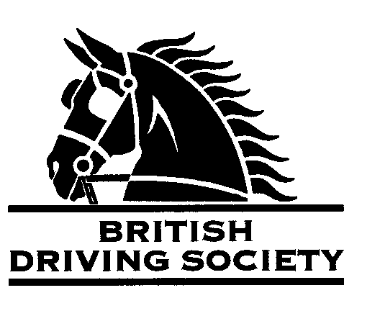

DRIVE FROM TICKLERTON VILLAGE HALL FOLLOWED BY BRING YOUR OWN PICNIC.

VENUE: TICKLERTON VILLAGE HALL TICKLERTON CHURCH STRETTON. VILLAGE HALL WILL BE OPEN.

LONG ROUTE 10.5 MILES AND SHORT ROUTE 7.5MILES.

POST CODE:

**SY6 7DQ**

DATE: **SUNDAY**

15TH JUNE 2025

TIME: ARRIVE 11.00AM FOR INDIVIDUAL START FROM

NOON OR EARLIER IF READY

ENTRY FEE:

**£5.00**

Maps and full instructions will be given at the commencement of the drive.

Neither the Organizing Committee nor the British Driving Society nor any Landowner nor any Agent, Employee or representative of these bodies accept any responsibility for any accident, loss, damage, injury or illness to any animal, person or property whatsoever, however caused.

The Society takes reasonable precautions to ensure the Health and Safety of everyone present at each event. For these measures to be effective everyone must take all reasonable precautions to avoid and prevent accidents occurring and must obey the instructions of the Organizer and all Officials and Stewards.

All drivers and participants must agree to abide by the Rules of the British Driving Society available at [*www.britishdrivingsociety.co.uk*](http://www.britishdrivingsociety.co.uk/).

*Individuals who are symptomatic or have been exposed to the Covid virus should not attend.*

Correctly fitted hard hats that meet the latest safety regulations are recommended and are mandatory for participants under the age of 14. All drivers must be aged 8 years or older and all participants under 18 must be accompanied by a responsible adult.

CLOSING DATE FOR ENTRIES………8**THJUNE 2025…………………………………………………………………**

Entry form for Event: DRIVE FROM TICKLERTON VILLAGE HALL 15TH JUNE 2025

NAME………………………………………………………………………………………………………………………………………………………

ADDRESS………………………………………………………………………………………………………………………….......................

…………………………………………………………………………………………………………POST CODE………………………………….

TELEPHONE No…………………………………………........…....MOBILE................................………………………….

Email………………………………………………………………………………………………………………………………….......................

I am a B.D.S. MEMBER, Membership No. …………………………..………..

Payment enclosed……………………………………………………… .(cheque payable to BDS Shropshire)

My horse is/is not vaccinated against Equine ‘flu (PLEASE COMPLETE)

SIGNED……………………………………………………PRINT NAME ………………………………………..............

Please return this slip with your cheque by ……….8TH JUNE 2025……………… to:

MRS B E COWIE MILL HOUSE MILL LANE NESS NESTON WIRRAL CHESHIRE CH64 8TH

Enquiries tel…0151 336 2505…………millhouse22@talktalk.net