**BRITISH DRIVING SOCIETY SHROPSHIRE AREA 27**

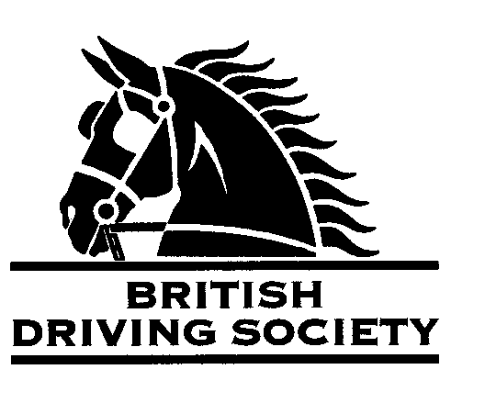

DRIVE FROM WINSLEY HALL BY KIND PERMISSION OF

MR C WHITAKER WITH PRESENTATION OF MOONSTROLLER TROPHY IN MEMORY OF JANE BRINDLEY AND MRS JUNE WHITAKER AND 11.7 MILE ROUTE IN MEMORY OF JOE DAVIES. SHORTER ROUTE AVAILABLE.

JOE DAVIES

VENUE: WINSLEY HALL WESTBURY SHROPSHIRE

**Please use BACK DRIVE situated between B4386 and B4387**

SMART DRESS FOR PRESENTATION OF TROPHY AND PLEASE BRING YOUR OWN PICNIC FOR AFTER THE DRIVE.

FOR AFTER THE DRIVE

POST CODE:

**SY5 9HB**

DATE: **SUNDAY**

13TH JULY 2025

TIME: ARRIVE 10.30AM FOR

PRESENTATION AT 11.30AM

FOLLOWED BY DRIVE

ENTRY FEE:

£5.00

Maps and full instructions will be given at the commencement of the drive.

Neither the Organizing Committee nor the British Driving Society nor any Landowner nor any Agent, Employee or representative of these bodies accept any responsibility for any accident, loss, damage, injury or illness to any animal, person or property whatsoever, however caused.

The Society takes reasonable precautions to ensure the Health and Safety of everyone present at each event. For these measures to be effective everyone must take all reasonable precautions to avoid and prevent accidents occurring and must obey the instructions of the Organizer and all Officials and Stewards.

Individuals should comply with Government guidelines regarding Covid 19 in place at the time. Hand sanitiser and wipes to be carried.

Individuals who are symptomatic or have been exposed to the virus should not attend.

All drivers and participants must agree to abide by the Rules of the British Driving Society available at *www.britishdrivingsociety.co.uk*

Correctly fitted hard hats that meet the latest safety regulations are recommended and are mandatory for participants under the age of 14. All drivers must be aged 8 years or older and all participants under 18 must be accompanied by a responsible adult.

CLOSING DATE FOR ENTRIES ………………….**6th JULY 2025**……………………………………………………

Entry form for Event: ……DRIVE FROM WINSLEY HALL on 13TH JULY 2025

NAME……………………………………………………………………………………………………………………………………………………..

ADDRESS………………………………………………………………………………………………………………………….......................

…………………………………………………………………………………………………………POST CODE…………………………………

TELEPHONE No…………………………………………........….....MOBILE................................…………………………

Email………………………………………………………………………………………………………………………………….......................

I am a B.D.S. MEMBER, Membership No. …………………………..………..

Payment enclosed……………………………………………………… …...(cheque payable to **BDS Shropshire**)

My horse is/is not vaccinated against Equine ‘flu (PLEASE COMPLETE).

SIGNED……………………………………………………PRINT NAME………………………………………...................................

Please return this slip with your cheque by…….6TH JULY 2025 to:

MRS B E COWIE MILL HOUSE MILL LANE NESS NESTON WIRRAL CHESHIRE CH64 8TH

Enquiries….0151 336 2505………………millhouse22@talktalk.net