BDS SHROPSHIRE AREA 27
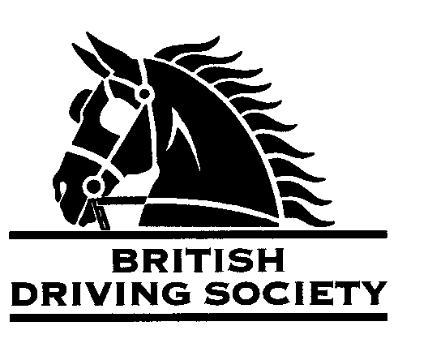

EVENT Rodington Easter Bonnets drive. 12 mile drive with halfway halt. Shorter route available. Please bring your own picnic for after the drive
VENUE Park in the yard next to the Bull’s Head, Hunkington Lane, Rodington SY4 4QS.
DATE 21st April 2025.
TIME 10am arrival. 10.45am judging of Easter bonnets and decorated carriages. Departure from 11am onwards.
ENTRY FEE £5

Maps and full instructions will be given at the commencement of the drive.

Neither the Organising Committee nor the British Driving Society nor any Landowner nor any Agent, Employee or representative of these bodies accept any responsibility for any accident, loss, damage, injury or illness to any animal, person or property whatsoever, however caused.
The Society takes reasonable precautions to ensure the Health and Safety of everyone present at each event. For these measures to be effective,everyone must take all reasonable precautions to avoid and prevent accidents occurring and must obey the instructions of the Organizer and all Officials and Stewards.

All drivers and participants must agree to abide by the Rules of the British Driving Society available at www.britishdrivingsociety.co.uk.

Correctly fitted hard hats that meet the latest safety regulations are recommended and are mandatory for participants under the age of 14. All drivers must be aged 8 years or older and all participants under 18 must be accompanied by a responsible adult.

CLOSING DATE FOR ENTRIES 12th April 2025

---------------------------------------------------------------------------------------------------------------------------------------------
Entry form for Rodington Easter Bonnets Drive 21st April 2025

NAME

ADDRESS

POST CODE

TELEPHONE No MOBILE

Email _

I am a B.D.S. MEMBER, Membership no._____________________________________________________________

Name of groom----------------------------------------------------------------------------------------------------------------------
Payment enclosed (cheque payable to BDS Shropshire) or online payment to British Driving Society Area 27 Lloyds Bank 30-96-26 Acc 801186600

My horse is/is not vaccinated against Equine ‘flu (PLEASE COMPLETE)

SIGNED---------------------------------------------------------------------------------------------------------------

Please return this slip with your cheque by 12th April 2025 to:
Philip Holder, Wellington Carriage Co., Long Lane, Wellington, TF6 6HD.
Phone 01952 242495, email philip@wellingtoncarriageco.co.uk

